<DATE>
Dear _____,
Your article, [name of article/link], published on [date], suggests that you and your staff are unaware of key information on the “gender-affirmative care” model. Below are critical points that any journalist concerned about gender dysphoric people needs to know.
- The findings and recommendations of the recently released Cass Review confirm what many of us have long known: that social, medical, and surgical interventions for gender distress lack evidence of benefit, and instead show significant evidence of harm. The report characterizes pediatric gender-transition treatment as based on “remarkably weak evidence” and indicates that the same holds true for adults. England and Wales will no longer prescribe puberty blockers. Headline from the London Times: “Prescription of puberty blockers to children is "Quack Medicine."
- When pressed to provide evidence that puberty suppression, cross-sex hormones, and surgeries lead to better health outcomes for teens, activist doctors invariably refer to the biggest gender-medicine lobby group in the world: WPATH — the World Professional Association for Transgender Health. With the release of the WPATH Files, this organization has been discredited for repeatedly and knowingly deviating from accepted medical ethics. According to their “Standards of Care, v. 8”, member clinicians are aware of the irreversible harm done to children and vulnerable adults, and include a section that recommends removing the genitals of people with a “eunuch” identity because it is "medically necessary." The shocking behavior of WPATH clinicians documented in the WPATH Files includes removing the genitals of a schizophrenic, homeless young man; the admission that testosterone likely caused liver cancer in a female child; and the admission that their teen patients and their parents are unable to comprehend the full risks and implications of the sex trait modification interventions they consent to.
Source: WPATH (chapter 9, p. 90), Genspect, BMJ The WPATH Files
- The globally influential Dutch model recommending puberty blockers, cross-sex hormones, and surgery, was never tested on the vast majority of those currently seeking “gender-affirming care” in the US and internationally — gender dysphoric teens and young people with multiple comorbid mental health diagnoses and neurocognitive challenges, but no prior, longstanding history of gender issues. Even Dutch gender clinicians lament the weakness in applying the 2006 findings to this rapidly growing population. The “Dutch studies,” which purport to show that puberty blockers improve the mental health of dysphoric patients, relied on grossly flawed methodologies that made drawing meaningful conclusions impossible, the results have not been replicated, and the research was funded by Ferring Pharmaceuticals, the company that manufactures them.
Source: The Free Press, SEGM, Genspect, NRC, Voorzij.nl
The only other clinic that has attempted to replicate the Dutch findings was the UK’s Tavistock clinic. The latest data show that 29% of the patients improved. 34% deteriorated, and 37% stayed the same. 71% did not improve. More got worse than got better.
Source: BBC, Newsnight
- Finland stopped recommending puberty blockers and cross-sex hormones in 2020 after conducting a systematic review of the evidence. The Finnish health authorities now recommend psychotherapy as the first-line treatment for gender dysphoria to avoid lifelong medicalization.The majority of patients with classical, childhood-onset gender dysphoria (61%-98%) desist from transgender identification some time in adolescence or young adulthood (Korte et al., 2008; Steensma, McGuire, Kreukels, Beekman, and Cohen-Kettenis, 2013; Zucker, 2018), suggesting that going through puberty itself is the most effective and least invasive way to resolve childhood onset gender dysphoria. That approach, known as “watchful waiting,” was the most widely accepted model in the Western world prior to the Dutch studies in 2011 and 2014. Even for the 20% of patients who continue to identify as trans into adulthood, there is no evidence that puberty suppression improves their well-being.
Source: SEGM, Helsingin Sanomat, The Free Press
- Sweden's National Board of Health and Welfare conducted a systematic review in 2021 and found that the risks of puberty blockers and hormones outweigh the possible benefits.
Source: SocialStyrelsen, SBU, Acta Paediatrica
- Norway's Healthcare Investigation Board (Ukom) has declared puberty blockers and cross-sex hormones "experimental treatment" and the top gender doctor at Oslo University Hospital (Anne Wæhre) has been trying to warn about “unjustifiable” treatment guidelines for years.
Source: Ukom, BMJ, Aftenposten 1, Aftenposten 2, Aftenposten 3, WSJ
- Denmark is backtracking as well. Citing limitations in the 2011/2014 Dutch studies and the impact of social influence on teen self-identification as well as the rise in detransitioners, Denmark has sharply restricted eligibility for hormone interventions for youth.
Source: SEGM, Ugeskrift for Læger (Journal of the Danish Medical Association)
- In light of the Cass review, Belgium and the Netherlands are now questioning the received wisdom of the gender affirmative care model. A report by three Belgian psychiatrists and a pediatrician declares that “Belgium must reform gender care in children and adolescents following the example of Sweden and Finland, where hormones are regarded as the last resort.”
- The myth that you can have a trans kid or a dead kid has been debunked. A recent landmark study from Finland found that suicide was rare among dysphoric youth. The study also revealed that medical transition did not appear to reduce suicide risk; that in fact psychiatric co-morbidities accounted for the elevated suicide risk among gender clinic patients, not gender dysphoria.
- The American Academy of Pediatrics promotes the affirmative model, which recommends puberty blockers to treat gender dysphoria, followed by hormones and surgeries. This AAP guidance was written by a single doctor, Jason Rafferty, who had barely finished his residency. There's even a disclaimer in the document saying Rafferty was the only person who "conceptualized, drafted, reviewed, revised, and approved" the guidance and that he "agrees to be accountable for all aspects of the work." Rafferty was empowered to submit his own work to himself for approval and then, incredibly, he approved it.
Source: AAP
- Rafferty's justification for these treatments contained numerous faulty citations. Upon closer inspection, the references actually show the very opposite of what he claims.
Source: James Cantor
- Many members of the American Academy of Pediatrics have been expressing concern about "gender-affirming care" for years and clamoring for a systematic review of the evidence, but they were repeatedly ignored by AAP leadership.
Source: SEGM, Julia Mason, "No Way Back" (min 11:13)
- Rafferty and two other high-profile gender clinicians and the American Academy of Pediatrics are currently being sued by a detransitioner for civil conspiracy, fraud, and medical malpractice. The AAP has quietly instructed members to stop using their work email accounts when communicating about “sensitive topics'' that might be revealed by subpoenas.
Source: Leor Sapir
In addition to repeating serious factual errors about the realities of sex-trait modification, the common narrative suggests that all progressives are aligned on the issue of gender. The many liberals who value evidence-based care and who want the rights of women and girls protected would disagree. As mainstream Democrats learn more about gender-identity ideology, polling shows support on these issues is waning.
Democratic voter opinion overall is also changing. An indication is in the level of support for trans-identified males competing in female sports — Democratic voter support for those males dropped eight percentage points between 2021 and 2023.
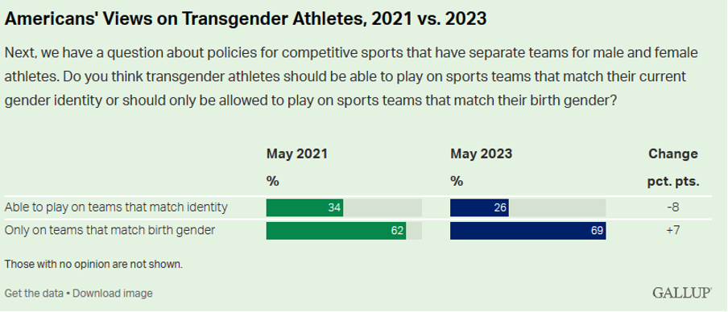
Gallup Poll Released June 12, 2023
We urge all journalists to cover this issue by following the science, not the ideology, and we hope the above information is helpful in your future reporting.
Thank you for your time. If any of these points contain errors, I hope you will debunk them.
Best regards,
<YOUR NAME (optional)>
<YOUR CONTACT INFO (optional)>

